Prerequisites

Software:

InstallthepythonIDLE:

Step-1

Pythoninstallationv-3.7.0(64bit)

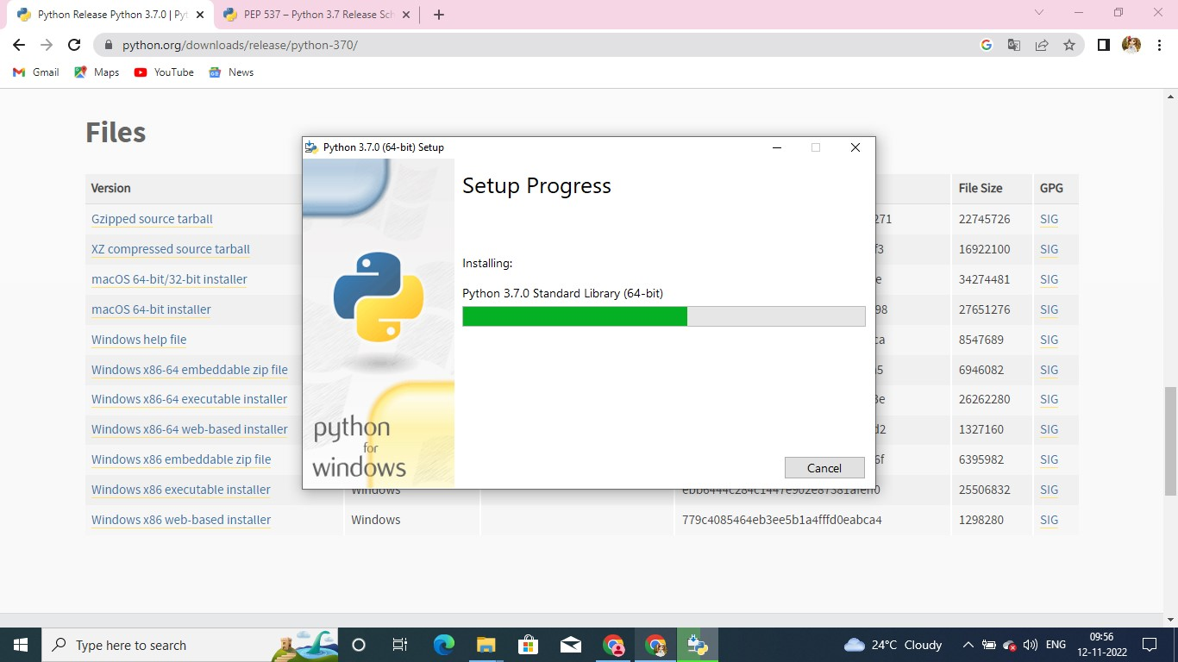

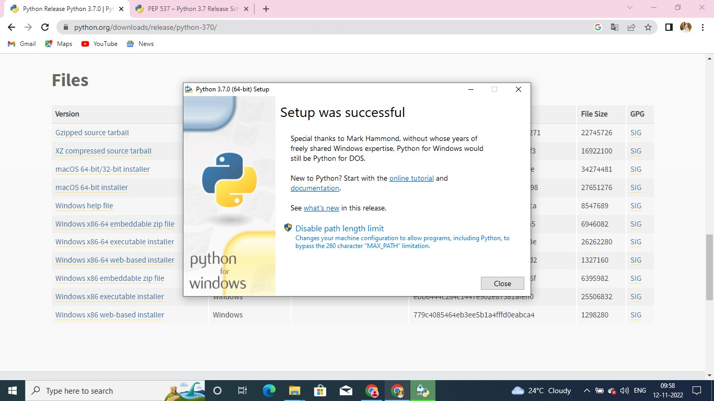

Step-2:

•Pipinstallwiotp-sdk

•Pipinstallibmcloudant

•Pipinstallopencv-python

•Pipinstallpyzbar

